征文 | “2022年第十一届数量经济学国际学术会议（中国•长春）”
征文启事
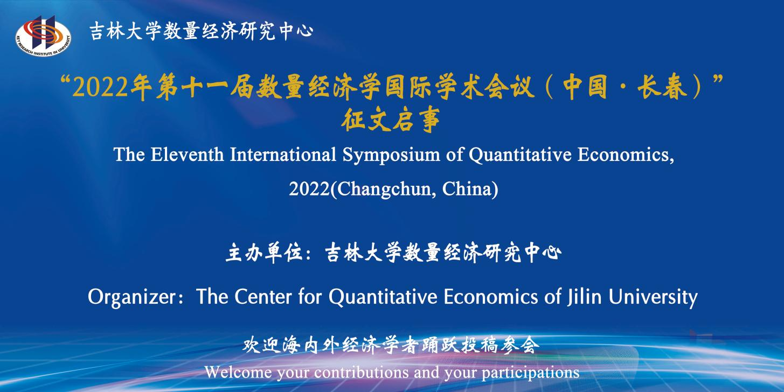 “2022年第十一届数量经济学国际学术会议（中国•长春）”
征文启事
“2022年第十一届数量经济学国际学术会议（中国•长春）” ，拟于2022年7月8日-7月10日举行，会议英文名称为：The Eleventh International Symposium of Quantitative Economics, 2022 (Changchun, China)。本届国际会议拟围绕当前中国经济与世界经济问题，重点关注数量经济学理论与方法的最新进展及其在经济、金融各领域的应用，致力于为全球经济学和金融学等研究领域的专家学者提供高水平学术交流的国际化平台。会议期间将特邀海内外著名学者举办国际前沿学术论坛。会议征文选题包括但不限于：宏观经济计量与数量分析、微观经济计量与数量分析、金融市场计量与数量分析等。本次会议得到了《数量经济技术经济研究》、《数量经济研究》和International Review of Economics and Finance等中英文学术期刊的大力支持。主办方将与以上期刊建立学术委员会对投稿论文进行匿名评审，择优入选会议论文。其中经会议交流推荐和期刊认可的论文可直接进入对应期刊的匿名审稿流程。欢迎海内外学者踊跃投稿参会。
投稿方式
会议论文投稿采用邮箱投稿方式。投稿邮箱为sljj@jlu.edu.cn。截止日期为2022年6月1日。投稿格式：投稿论文请使用PDF格式（中英文均可），投稿体例见附件；邮件发送主题请以“2022年会+作者姓名”方式命名（英文稿件以"2022 Conference + Author’s Name"命名）；请将作者姓名、单位、职称、联系电话、通讯地址、电邮地址等信息置于论文首页。如果想进入《数量经济技术经济研究》、《数量经济研究》和International Review of Economics and Finance等期刊匿名审稿流程请在投稿邮件中添加附件中的会议期刊投稿说明。投稿论文经会议学术委员会匿名评审后，于2022年6月5日至10日期间陆续向所有入选论文的通信作者发送会议邀请函。
会议联系方式
联系电话：0431-85166059；联系邮箱：sljj@jlu.edu.cn。
主办单位
吉林大学数量经济研究中心
协办期刊
数量经济技术经济研究
International Review of Economics and Finance
数量经济研究
附件1：投稿体例
1. 中文写作体例参考《数量经济技术经济研究》投稿要求，参见
http://www.jqte.net/sljjjsjjyj/ch/index.aspx
2. 英文写作体例参考International Review of Economics and Finance投稿要求，参见
https://www.elsevier.com/journals/international-review-of-economics-and-finance/1059-0560/guide-for-authors

附件2：会议期刊投稿说明
请说明您论文的投稿意向，如果投稿论文不参加会议期刊匿名审稿流程请在A选项后的括号中打√；如果参加会议期刊匿名审稿流程，请在B、C或D选项后的括号中打√，可多选。

A.论文只参加会议交流，不参加期刊匿名审稿流程 （ ）
B.论文申请参加《数量经济技术经济研究》的匿名审稿流程 （ ）
C.论文申请参加《数量经济研究》的匿名审稿流程 （ ）
D.论文申请参加International Review of Economics and Finance的匿名审稿流程（ ）
The Eleventh International Symposium of Quantitative Economics, 2022(Changchun, China)
July 8-10, 2022
The Eleventh International Symposium of Quantitative Economics, 2022 (Changchun, China) is scheduled to be held from July 8 to 10, 2022 in Changchun, China. The symposium has its main concerns with the current Chinese and world economic issues, focusing on the latest developments in quantitative economics theories and methods and their applications in all economic and financial areas, and is committed to creating a high-level academic platform for global economics and finance scholars, who demonstrate and exchange new ideas and original points, and discuss the latest cutting-edge research results. During the symposium, distinguished domestic and overseas scholars will be invited to chair international frontier academic forums. The topics of the symposium include but are not limited to: macroeconomic econometric and quantitative analysis, microeconomic econometric and quantitative analysis, and financial market econometric and quantitative analysis. The symposium received strong support from reputable journals including Journal of Quantitative and Technical Economics, Journal of Quantitative Economics, and International Review of Economics and Finance. The organizer will establish an academic committee with the above journals to review the submitted papers anonymously and elect the best ones as the conference papers. Among them, the papers accepted by both the conference and the journals can directly enter the anonymous manuscript review process of the corresponding journals. Welcome your contributions and your participations.
Call for Papers
Welcome to submit unpublished papers to our conference through email: sljj@jlu.edu.cn. Please use PDF format (either in English or Chinese). The subject of the email is supposed to be named as "2022 Conference + Author’s Name". Please be sure to include the following information in first page of your manuscript: author's name, organization, job title, contact number, mailing address, email address. If your paper wants to enter the anonymous review process for Journal of Quantitative and Technical Economics, Journal of Quantitative Economics, or International Review of Economics and Finance, please add the submission instruction for journal in the attachment to the submission email.
Submission Due: June 1, 2022.
Feedback: We will send the conference invitation letters to all the corresponding authors of the selected papers during June 5 to 10, 2022.
Contact Information
Phone: 0431-85166059
E-mail: sljj@jlu.edu.cn
Organizer
The Center for Quantitative Economics of Jilin University
Co-organizer
Journal of Quantitative and Technical Economics
International Review of Economics and Finance
The Journal of Quantitative Economics
Appendix 1：Submission Style
1. The writing style of Chinese submission refers to the submission requirements of Journal of Quantitative and Technical Economics. Please see
http://www.jqte.net/sljjjsjjyj/ch/index.aspx
2. The writing style of English submission refers to the submission requirements of International Review of Economics and Finance. Please see
https://www.elsevier.com/journals/international-review-of-economics-and-finance/1059-0560/guide-for-authors

Appendix 2：The Submission Instruction for Journal
Please indicate your choice for submission. If your submission does not want to enter the anonymous review process of the journals supporting the symposium, please tick √ in the brackets after option A; if you want to enter the anonymous review process of the journals supporting the symposium, please tick √ in the brackets after the option B, C or D. You may choose more than one options.

A. The submission is exchanged at the symposium, but doesn’t enter the review process of the journals （ ）
B. The submission applies to enter the anonymous review process of Journal of Quantitative and Technical Economics （ ）
C. The submission applies to enter the anonymous review process of Journal of Quantitative Economics （ ）
D. The submission applies to enter the anonymous review process of International Review of Economics and Finance （ ）
附件2完整版请点击下载
Please click to download the full version of appendix 2

